**WEEKLY REPORT DE BENEDETTI MATTEO**

**WEEK 15: 09/12/2019 - 13/12/2019**

IMAGE OVERLAP PERCENTAGE:

The Image Overlap Percentage (IOP) does not change for the same IFD at different speed, as long the camera position and orientation is constant.

|  |  |
| --- | --- |
| IFD [meters] | IOP [percentage] |
| 0.01 | 93.983 |
| 0.03 | 92.34 |
| 0.06 | 89.903 |
| 0.1 | 86.704 |
| 0.2 | 78.959 |
| 0.3 | 71.575 |
| 0.5 | 57.887 |
| 0.75 | 42.809 |
| 1.0 | 29.983 |

TEST FAST WITH INCREASING IFD:

The first tests changing the VO frequency, so the Inter-Frame Distance (IFD), were run on a sequence at the SFR speed of 0.07 m/s.

The results show that from and IFD of 0.2m and IOP of ~78% and bigger the VO starts to lose accuracy both in the position and orientation estimate, while for smaller values of IFD it performs well and with no visible variations.





TEST SLOW SPEED WITH INCREASING IFD:

The same IFD values were also tested on a traverse at low speed (0.02 m/s) which would then require much longer periods to achieve the same IFD than a 0.07 m/s traverse.

The results show that again starting from an IFD of 0.2m and IOP of ~78% the performances of the VO start to deprecate.





All in all, the results of the tests at high and low speed would suggest that, in the conditions of these experiments, as long as the IFD is not bigger than 0.2m and the IOP is not smaller than 78% there is no advantage in further increasing the VO frequency to try to achieve better performances, and that the VO performances are not dependent on the VO frequency but on the IFD and IOP.

COMPARING SLOW AND FAST SPEED AT DIFFERENT IFD:

For a better visualization and to also see if the IFD has an effect on the performances that depends of the speed, the results for the same IFD in high and low speed have been plotted together

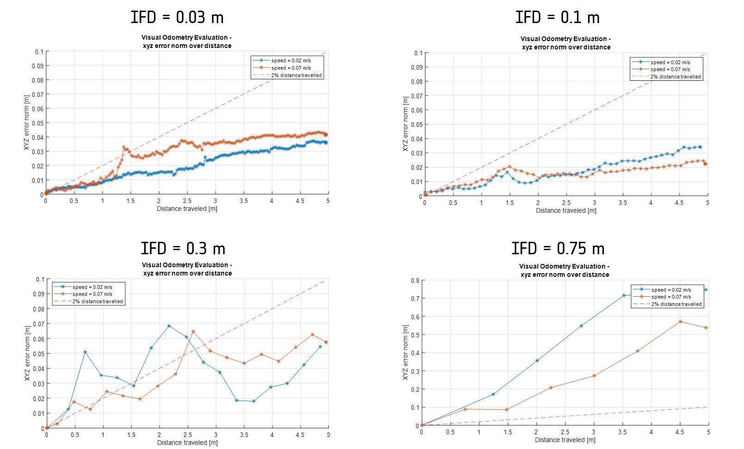

The plots clearly show that the VO performances are affected by the IFD in a very similar way whether the rover is moving at a high or low speed.

WORKING ON THE PTU:

I have also been working on integrating the camera on top of the PTU in the VO pipeline I developed for the tests, importing the new parameters, connecting the appropriate tasks, adding the possibility of controlling the PTU angles in the motion_generator component, setting up the dynamic transform from the ExoTeR body to the camera on the PTU and resetting the zero of the PTU motors.

FUTURE OBJECTIVES:

In the next week I plan on starting the tests using the PTU camera where I will be able to see the effect of changing the pitch and therefore the image overlap.